**Chapter 2 In-Class Exercise**

Marcia Wilson owns and operates *Marcia’s Dry Cleaning*, which is an upscale dry cleaner in a well-to-do suburban neighborhood. Marcia makes her business stand out from the competition by providing superior customer service. She wants to keep track of each of her customers and their orders. Ultimately, she wants to notify them that their clothes are ready via e-mail. To provide this service, she has developed an initial database with several tables. Three of those tables are the following:

**CUSTOMER (CustomerID, FirstName, LastName, Phone, Email)**

**INVOICE (InvoiceNumber, *CustomerNumber*, DateIn, DateOut, TotalAmount)**

**INVOICE_ITEM (*InvoiceNumber*, ItemNumber, Item, Quantity, UnitPrice)**

In the database schema above, the primary keys are underlined and the foreign keys are shown in italics. The database that Marcia has created is named MDC, and the three tables in the MDC database schema are shown below.

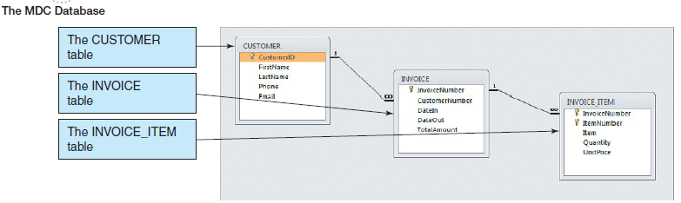

Tables detailed column characteristics are provided below.

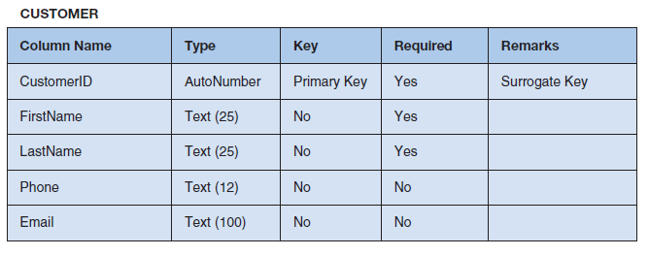

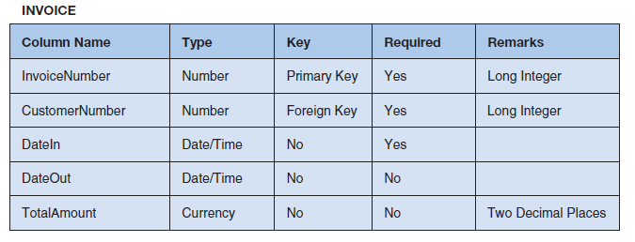

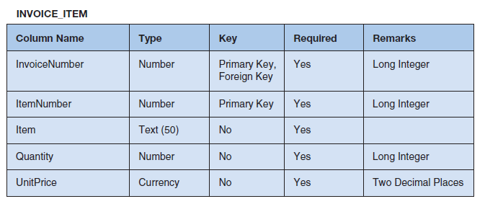

Write SQL statements and show the results based on the MDC data for each of the following:

1. Show all data in each of the tables.

**Select * from customer;**

**Select * from invoice;**

**Select * from invoice_item;**

1. List the LastName, FirstName, and Phone of all customers.

**Select LastName, FirstName, Phone from Customer;**

1. List the LastName, FirstName, and Phone for all customers with a FirstName of ‘Nikki’.

**Select LastName, FirstName, Phone from Customer Where FirstName='Nikki';**

1. List the LastName, FirstName, Phone, DateIn, and DateOut of all orders in excess of $100.00.

**Select LastName, FirstName, Phone, DateIn, DateOut from Customer, Invoice Where TotalAmount>100 and Customer.CustomerID=Invoice.CustomerNumber;**

1. List the LastName, FirstName, Phone of all customers whose first name starts with ‘B’.

**Select LastName, FirstName, Phone from Customer where FirstName LIKE 'B%'**

1. List the LastName, FirstName, and Phone of all customers whose last name includes the characters ‘cat’.

**Select LastName, FirstName, Phone from Customer where LastName LIKE '%cat%';**

1. List the LastName, FirstName, and Phone for all customers whose second and third digits (from the left) of their phone numbers are 23. For example, any phone number with an area code of ‘723’ would meet the criteria.

**Select LastName, FirstName, Phone from Customer Where Phone Like '_23%';**

1. Determine the maximum and minimum TotalAmount.

**Select Max(TotalAmount) AS MaxTotalAmount, Min(TotalAmount) AS MinTotalAmount from Invoice;**

1. Determine the average TotalAmount.

**Select AVG(TotalAmount) as AvgTotalAmount from Invoice;**

1. Count the number of customers.

**Select Count(*) AS NumberOfCustomers from Customer**

1. Group customers by LastName and then by FirstName.

**Select LastName, FirstName from Customer Group BY LastName, FirstName**

1. Count the number of customers having each combination of LastName and FirstName.

**Select LastName, FirstName, Count(*) As Last_First_Combination_Count from Customer Group By LastName, FirstName**

1. Show the LastName, FirstName, and Phone of all customers who have had an order with TotalAmount greater than $100.00. Use a subquery. Present the results sorted by LastName in ascending order and then FirstName in descending order.

**Select LastName, FirstName, Phone from Customer Where CustomerID in (Select CustomerID from Invoice Where TotalAmount > 100) Order by LastName, FirstName DESC;**

1. Show the LastName, FirstName, and Phone of all customers who have had an order with TotalAmount greater than $100.00. Use a join. Present results sorted by LastName in ascending order and then FirstName in descending order.

**Select Customer.LastName, Customer.FirstName, Customer.Phone from Customer, Invoice Where Customer.CustomerID=Invoice.CustomerNumber and TotalAmount >100 Order By LastName, FirstName DESC;**

1. Show the LastName, FirstName, and Phone of all customers who have had an order with an Item named ‘Dress Shirt’. Use a subquery. Present results sorted by LastName in ascending order and then FirstName in descending order.

**Select LastName, FirstName, Phone from Customer Where CustomerID in (Select CustomerID from Invoice Where InvoiceNumber IN (Select InvoiceNumber from Invoice_Item where Item = 'Dress Shirt')) Order By LastName, FirstName DESC;**

1. Show the LastName, FirstName, and Phone of all customers who have had an order with an Item named ‘Dress Shirt’. Use a join. Present results sorted by LastName in ascending order and then FirstName in descending order.

**Select Customer.LastName, Customer.FirstName, Customer.Phone from Customer, Invoice, Invoice_Item Where Customer.CustomerID=Invoice.CustomerNumber and Invoice.InvoiceNumber = Invoice_Item.InvoiceNumber and Invoice_Item.Item = 'Dress Shirt' Order by LastName, FirstName DESC;**

1. Show the FirstName, LastName, and TotalAmount of all customers who have had an order with an Item named ‘Dress Shirt’. Use a join with a subquery. Present results sorted by LastName in ascending order and then FirstName in descending order.

**Select customer.firstname, customer.lastname from customer, invoice where customer.customerid=invoice.customernumber and invoice.invoicenumber in (Select invoicenumber from invoice_item where item='Dress Shirt') order by Customer.LastName ASC, Customer.FirstName DESC**